# SpringBoot Assessment

Welcome to the course assessment for the Java & Spring Boot for Web Development module!

In this session, you will complete a project about creating a Todo list.

By the end of this session, you will be able to:

● Build a full stack application using Java.

● Complete a Spring project.

Setup your spring project using org.generation as the company name.

Name your spring project as SpringBootAssessment.

You will develop a Simple Spring MVC Todo management web application using Spring Boot, Spring MVC, JPA and MySQL as a database.

1. Show all Todo list : Create a web page to display all Todo lists (the following UI is for illustration purposes. Feel free to do your own UI with the required information shown)

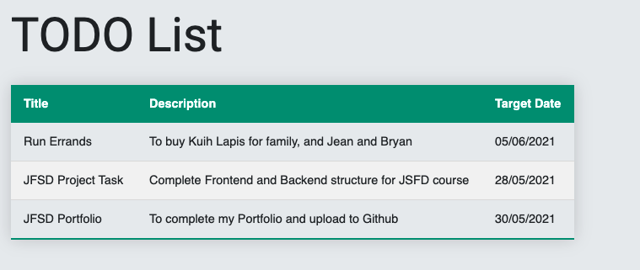

The table will list out all the information for the Todo list. Information to be retrieved from MySQL database.

1. Add Todo list: Create a web page to allow users to add their Todo list (the following UI is for illustration purposes. Feel free to do your own UI with the required information shown) - validation of the form fields are not required.

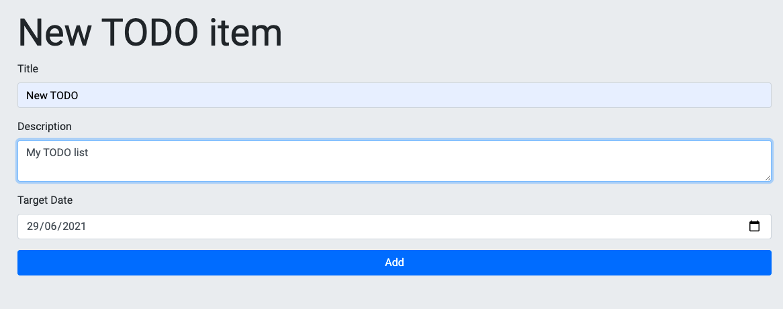

The form allows users to enter their Todo list details. When users click on the ‘Add’ button, the newly entered information will be added to the MySQL database.

1. Create a simple menu to navigate to the 2 pages (Show TODO list and Add TODO list). Do not need to use BootStrap, just 2 basic links on the 2 pages will do. Do not require to use the Thymeleaf template engine for code fragments, you may use the Thymeleaf for URL Mapping.
2. Submit your .mwb file together with your project folder.

Please place your SpingBoot solution in your github

After completing it, make sure you come back to complete a reflection.

**Directions:**

● **Send** the link of your github repository to (set your repo name as springAssessment)

* [genfsd2021@gmail.com](mailto:genfsd2021@gmail.com)
* [ernest36912@gmail.com](mailto:ernest36912@gmail.com)

● **Reflect** on the following questions.

**Questions:**

● **What did you like about this project?**

● **What did you struggle with in this project?**

● **What would make your experience with this assessment better?**

**Deadline: 14 June 2022, 5pm**

